**Part 1: The Blood**

Doesn’t the blood, in fact, indirectly ‘‘connect’’ practically all of our body parts together? The reason, obviously, is that the blood is the fluid connective tissue that circulates throughout the human corpus, thereby linking body structures together (in a physiological sense rather than strictly anatomical one). Blood is further classified as a ‘‘special’’ connective tissue because of the unique nature of the intercellular material between its cells – the plasma (PLAZ-muh). Plasma is the clear, watery, liquid ‘‘matter’’ (plasm) of both the blood and the lymph (LIMF) connective tissues. Therefore, after we examine the blood or ‘‘red stuff,’’ we will be obliged to do the same for the lymph or ‘‘clear spring water.’’

To briefly capsulize, blood is a red, sticky connective tissue with a fluid intercellular matter or matrix (the plasma) that occupies about 4–6 liters of volume in the average-sized adult.

What is the difference between blood and lymph?



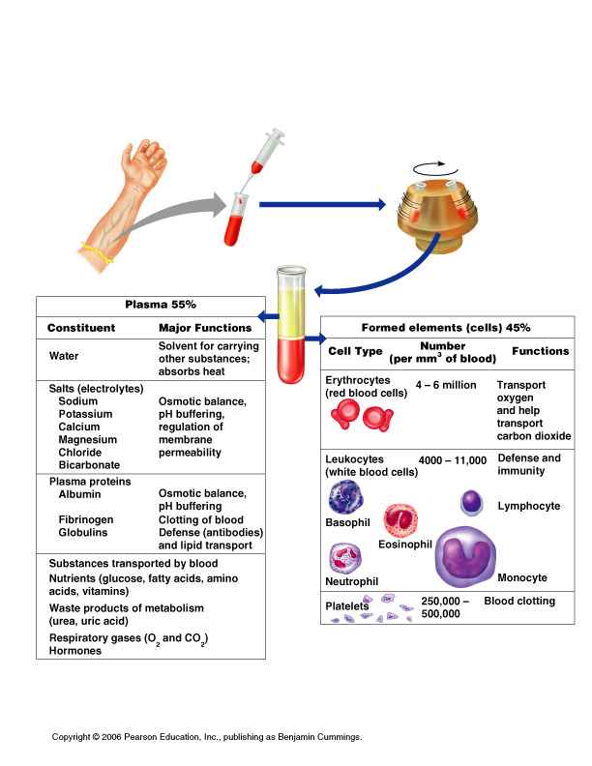



**Describe in your own words what blood is made of:**

**What types of cells are found in the blood?**



**Proteins found within the plasma:**



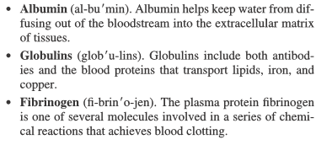



**Color range:** Oxygen-rich blood is scarlet red



Oxygen-poor blood is dull red



* pH must remain between 7.35–7.45
* Blood temperature is slightly higher than body temperature

**Using the diagram on the previous page, what are the 3 “formed” elements of blood?**



**Compare the # of different cell types found among the formed elements:**



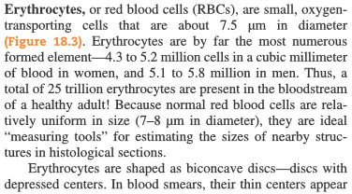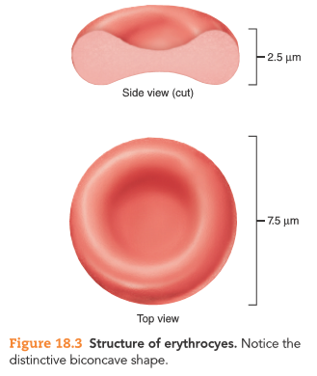**Erythrocytes (Red Blood Cells)**



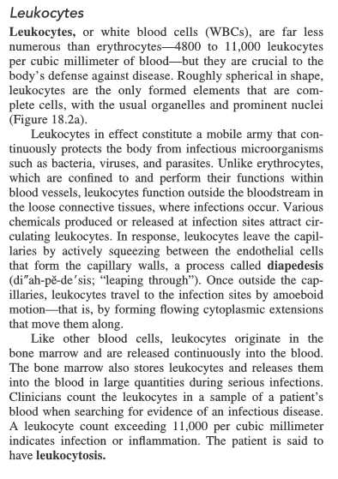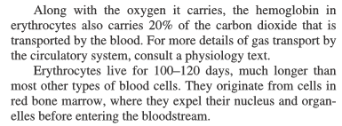**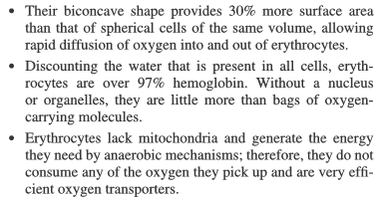Structural Characteristics of RBCs:**



**Approx how many leukocytes are present per cubic mm of blood?**

**What is the main FUNCTION of leukocytes?**

**Complete cells? Or lacking nuclei?**

**Explain diapedesis:**

**What is ameboid motion?**

**What is the function of hemoglobin in red blood cells?**

**What is the function of the biconcave shape of the RBCs?**

**Why are RBCs so good at transporting oxygen?**



**Abnormal leukocyte levels**

* + Leukocytosis: Above 11,000 leukocytes/ml, Generally indicates an infection
  + Leukopenia: Abnormally low leukocyte level, Commonly caused by certain drugs

**Explain why platelets are not really considered cells:**

**What is the main function of platelets?**

**What is clotting and when does it occur?**

